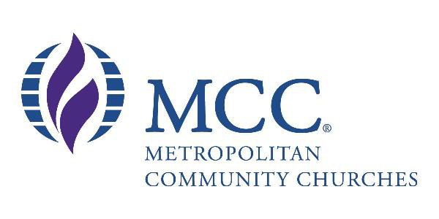

METROPOLITAN COMMUNITY CHURCH BRISBANE IS STARTING ITS YOUTH GROUP EVERY FRIDAY NIGHT!
AGE’S THAT ARE WELCOME: 12- 25
LOCATION: 37 Cordelia St, South Brisbane
TIME: 6.45PM-9PM
STARTING DATE: June 10th 2011
NO MATTER WHAT SKIN COLOUR YOU ARE, OR WHAT SEXUALITY, RACE, EVEN GENDER YOU IDENTIFY AS, YOU ARE ALL WELCOME WE HOPE TO SEE YOU ALL THERE!
Note that this area is an Alcohol and Drug free area
Designated Smoking areas are on Site

Safe Zone

