Transforming Families Website Launch
Social Media Toolkit
Parents of young people questioning their gender identity, or who identify as gender diverse, now have access to evidence-based resources to help support their child’s mental wellbeing, thanks to the Transforming Families website.
A Telethon Kids Institute-led collaboration with community organisations, the website provides practical, easily accessible information, and aims to improve mental health outcomes for trans children and young people. Much of the evidence has been taken from the following two papers; Knowledge is Power and Parental Challenges, Facilitators and Needs Associated with Supporting and Accepting Their Trans Child’s Gender.
To launch the site, we’re calling on partners to share a post to their corporate social media channels, which will help connect interested individuals to the website and its resources, highlighting the key message that Transforming Families is an academic and community collaboration, led by Telethon Kids Institute, to provide evidence-based information and resources to support parents of trans children and young people.
This project has been made possible thanks to funding from Healthway.

Social media

The Transforming Families Project Team is encouraging partners to support the launch of the website by posting one of the supplied social media posts to their channels from Monday, 29th May, or by sharing the social media posts created/shared on the official Telethon Kids Institute accounts.
When sharing campaign content, please tag Telethon Kids Institute with the relevant handles (see below) and share with the hashtag #TransformingFamilies

 | @TelethonKids |  | @telethonkids
 | @telethonkidsinstitute
Alternatively, you can “Share” any of posts from Telethon Kids Institute Facebook, Twitter, and Instagram accounts. To repost content via Instagram, you can download an app called ‘Repost’.

Campaign social media assets

All digital tiles, blurbs and banners can be downloaded via this link:
Copy and paste the Dropbox link below into your web browser for the link to work correctly!
https://www.dropbox.com/sh/qaqjms7fhnb2egw/AADBLEDwGf6PAKz2yUDOcNF3a?dl=0

Media release (live at 8:00 am on Monday 29th May):
https://www.telethonkids.org.au/news--events/news-and-events-nav/2023/may/new-resources-for-gender-diverse-children/
If you have any questions about our social media content or campaign materials, please contact the Transforming Families Project Manager, Helen Morgan.
Helen Morgan | Transforming Families Project Manager – Telethon Kids Insitute
Telephone: 08 6319 1298
Email: helen.morgan@telethonkids.org.au
Transforming Families Website Launch – social media content
Social media tiles and blurbs
Social tiles and links  Select your preferred graphic from the Dropbox link above – options included below. | Facebook copy, option one  Copy and paste the blurb directly into a Facebook post.  *Remember to “tag” @TelethonKidsInstitute in your post | Instagram copy, option one  Copy and paste the blurb directly into an Instagram post.  Links don’t work in Instagram posts, so add the link into your bio.  Let your followers know by saying something like “To find out more, click the link in our bio”.
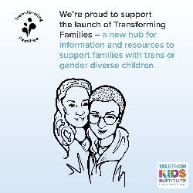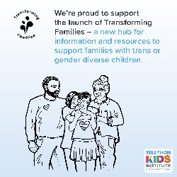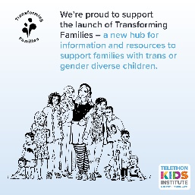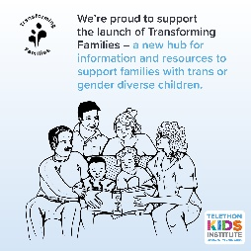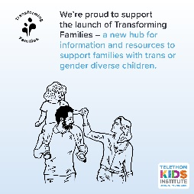 | We’re proud to be part of a national effort to improve resources in Australia for families of trans or gender diverse children.  Transforming Families is an academic and community collaboration, led by @Telethon Kids Institute and supported by @Healthway WA, providing evidence-based information and content to help families better support gender diverse (or questioning) young people.  Head over to transformingfamilies.org.au today to see the excellent resources on offer.  #TransResources #TelethonKidsInsitute #TransformingFamilies #GenderDiverse #GenderIdentity | We’re proud to be part of a national effort to improve resources in Australia for families of trans or gender diverse children.  Transforming Families is an academic and community collaboration, led by @telethonkidsinstitute and supported by Healthway to provide evidence-based information and resources to support parents of gender diverse (or questioning) young people.  To see the newly launched website, click the link in our bio.  #TransResources #TelethonKidsInsitute #TransformingFamilies #GenderDiverse #GenderIdentity  Add this link to your bio:  transformingfamilies.org.au
 | Facebook copy, option two (cont. on next page) | Instagram copy, option two (cont. on next page)
 | Research shows that parental support is key to achieving positive health and wellbeing outcomes for children and young people questioning their gender identity or who identify as gender diverse.  @Telethon Kids Institute have just launched #TransformingFamilies – a wonderful new resource helping families provide better support to their loved ones.  Visit the website today for evidence-backed resources and info: transformingfamilies.org.au  #TransResources #TelethonKidsInsitute #TransformingFamilies #GenderDiversity | Research shows that parental support is key to achieving positive health and wellbeing outcomes for children and young people questioning their gender identity or who identify as gender diverse.  @telethonkidsinstitute have just launched #TransformingFamilies – a wonderful new resource helping families provide better support to their loved ones.  Visit the website today for evidence-backed resources and info – click the link in our bio.  #TransResources #TelethonKidsInsitute #TransformingFamilies  Add this link to your bio:  transformingfamilies.org.au

Social tiles and links  Select your preferred graphic from the Dropbox link above – options included below. | Twitter copy, option one  Copy and paste the one of the following blurbs directly into your Twitter post; adjust tone as per your preferences. There’s a maximum of 280 characters (including spaces) permitted.
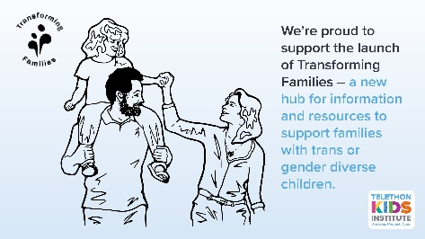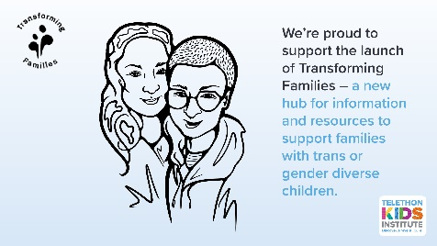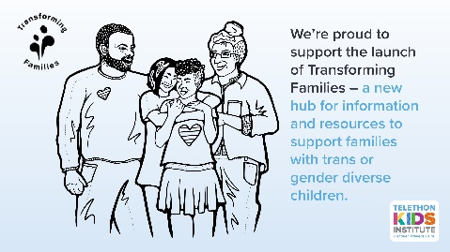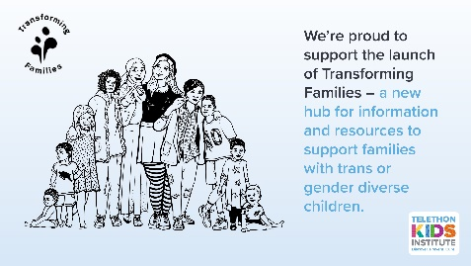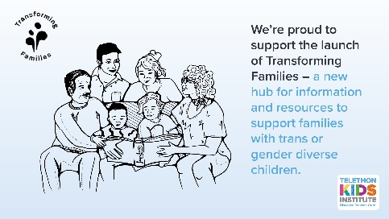 | #TransformingFamilies is a fantastic new resource for Aussie families of children and young people questioning their gender identity, or who identify as gender diverse. Check it out today! transformingfamilies.org.au  Please tag:  The following accounts in either the photo or as your first comment: @telethonkids, @transcend_aust, @PGDCsupport, @ACONhealth, @CCYPWA, @TransFolkWA, @thegendercentre and @HealthwayWA
 | Twitter copy, option two
An exciting new resource from @telethonkids has just launched, aimed at providing better support to Australian families and #GenderDiverse young people. Discover #TransformingFamilies and the wealth of resources on offer: transformingfamilies.org.au

Please tag:
The following accounts in either the photo or as your first comment: @telethonkids, @transcend_aust, @PGDCsupport, @ACONhealth, @CCYPWA, @TransFolkWA, @thegendercentre and @HealthwayWA

 | Twitter copy, option three
Families can now access dedicated resources and information to support children who are questioning their gender identity, or who identify as #GenderDiverse.
Check out #TransformingFamilies today: transformingfamilies.org.au

Please tag:
The following accounts in either the photo or as your first comment: @telethonkids, @transcend_aust, @PGDCsupport, @ACONhealth, @CCYPWA, @TransFolkWA, @thegendercentre, @HealthwayWA and @XXX

